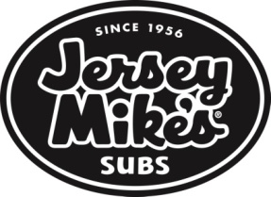

Dear ROCKVILLE HS Staff and Families,
The BOOSTERS are having a fundraiser at Jersey Mike' on WEDNESDAY, OCTOBER 19TH. Please come out and support the Boosters.
You may order online, by phone, OR in the store with dine in or carry out. You can order online the day of or even the day before the fundraiser and give them your pick-up time and date of pick up. If you call the order in, make sure to let them know it’s for the “ROCKVILLE HS BOOSTERS”.
You may also use the APP and even have it delivered thru the APP. Just make sure when using the APP to put “ROCKVILLE HS BOOSTERS” IN THE NOTES.
The fund raiser runs all day on WEDNESDAY, OCTOBER 19TH from 10am-9pm- so take a break from cooking dinner or go for lunch. The BOOSTERS appreciate all your support.

Instructions on how to order online are below.

- Go to WINTERGREEN PLAZA/ROCKVILLE Jersey Mike's website:
https://www.jerseymikes.com/order/28017/
2) Order on WEDNESDAY, OCTOBER 19TH.
3) In the Checkout section of your order:
- Please put PICK UP DATE/TIME AND YOUR NAME
- Under 'Notes' please put: “ROCKVILLE HS BOOSTERS FUNDRAISER”
- Gift cards also count towards the fundraiser. They make great thank you, birthday or teacher gifts.
Thank you for all your support!
****PLEASE SHOW THIS FLYER OR MENTION THE FUNDRAISER AT CHECK OUT SO THAT WE GET CREDIT. THANK YOU.

